|  |  |
| --- | --- |
| **Assignment Date** | **28 September 2022** |
| **Student Name** | **BHUJA SHRI R** |
| **Student Roll Number** | **953619104007** |
| **Maximum marks** | **2 marks** |

**IBM ASSIGNMENT II**

**PHARMA SALES DASHBOARD**

**Task 1:Sales By Customer**

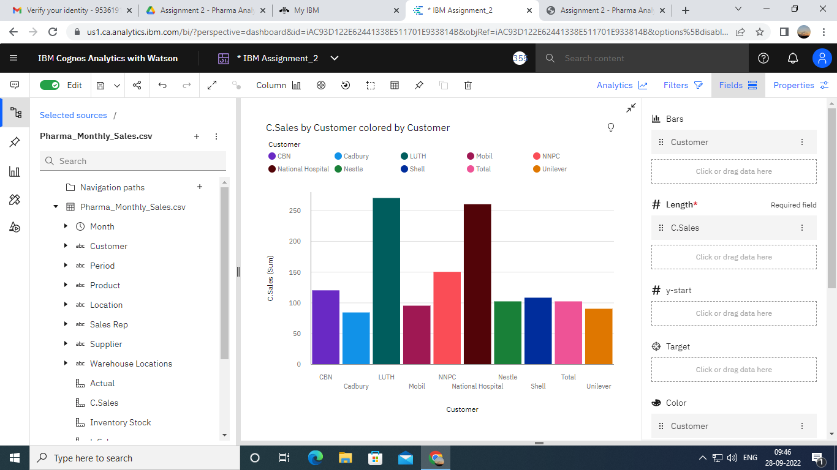

**Task 2:Sales By Location**

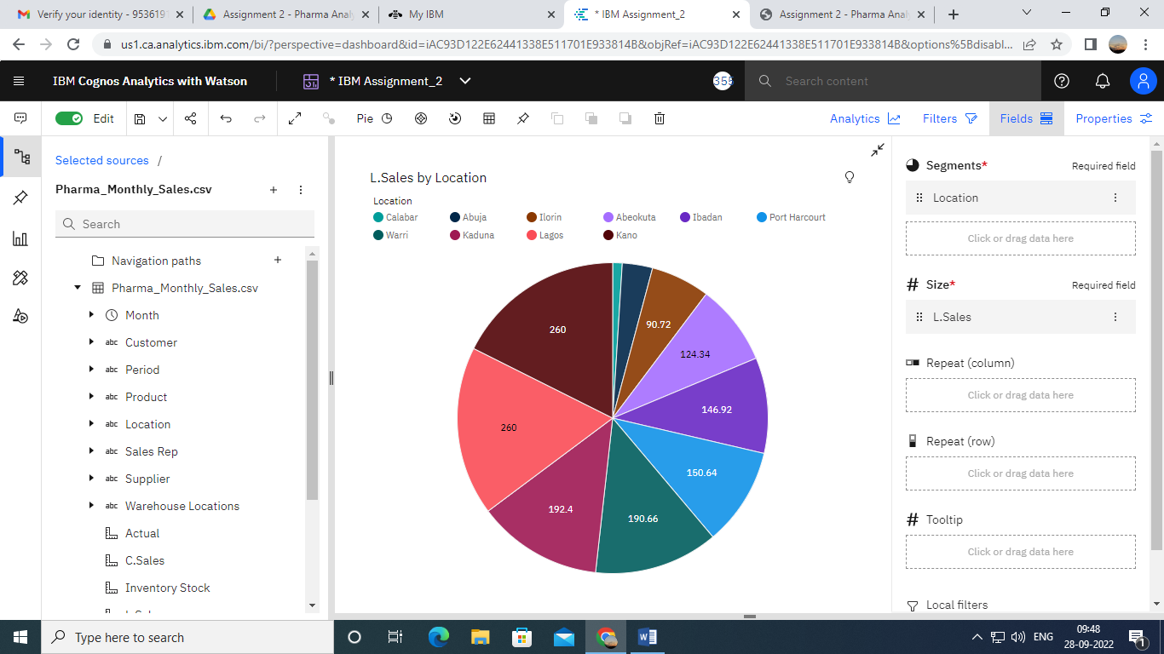

**Task 3:Sales By Sales Representative**

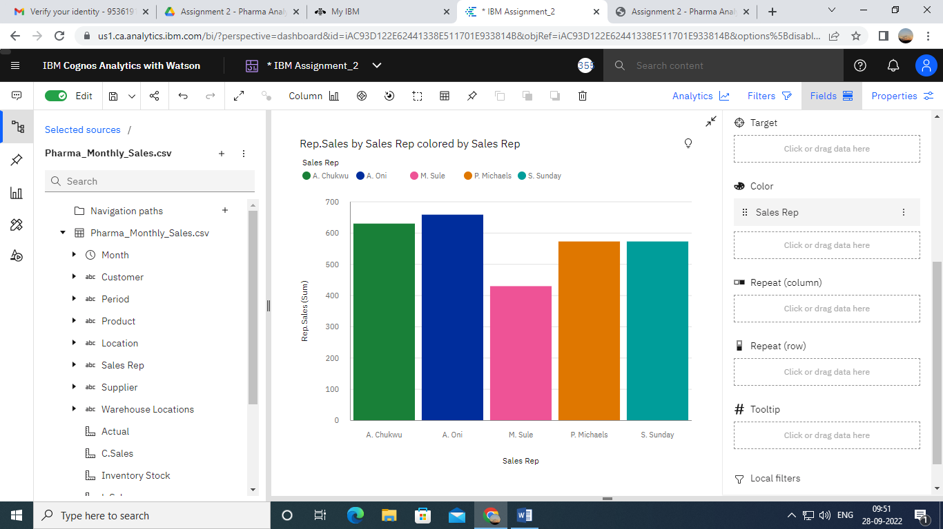

**Task 4: Received Inventory From Supplier**

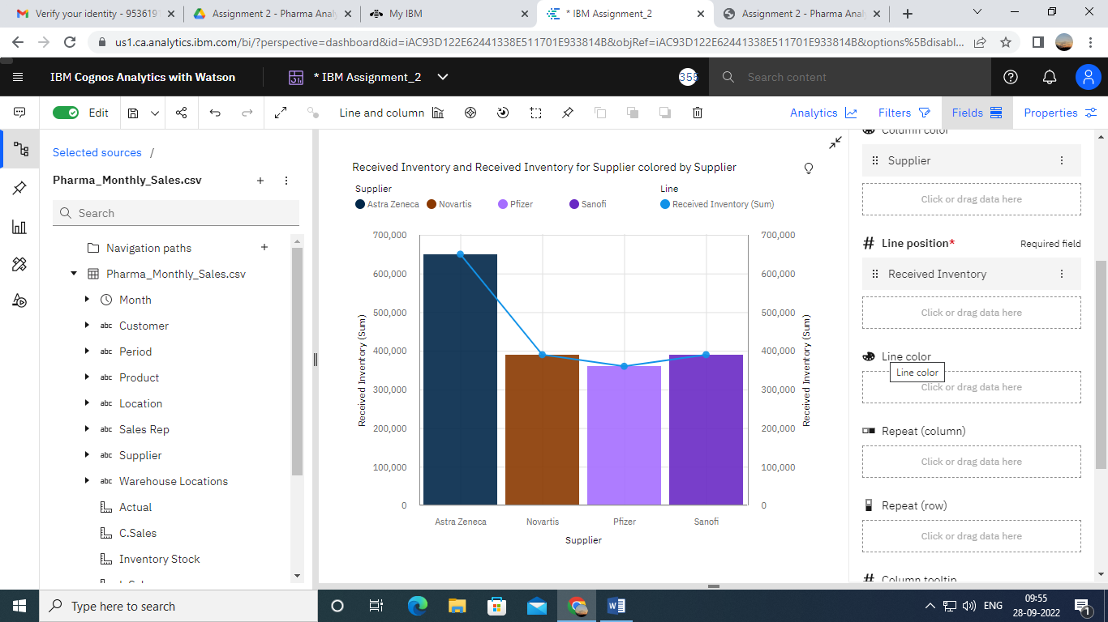

**Task 5: Inventory Stock for Warehouse Locations**

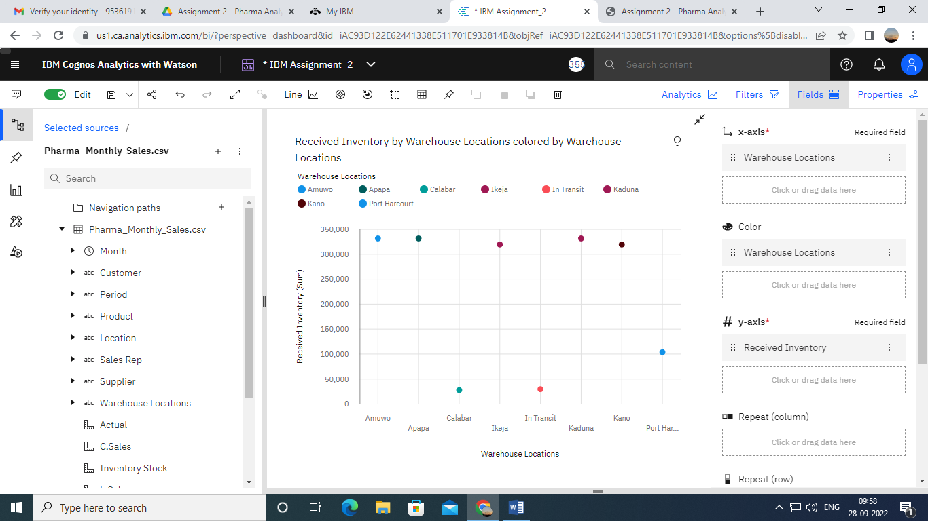

**Task 6: Sales Trend**

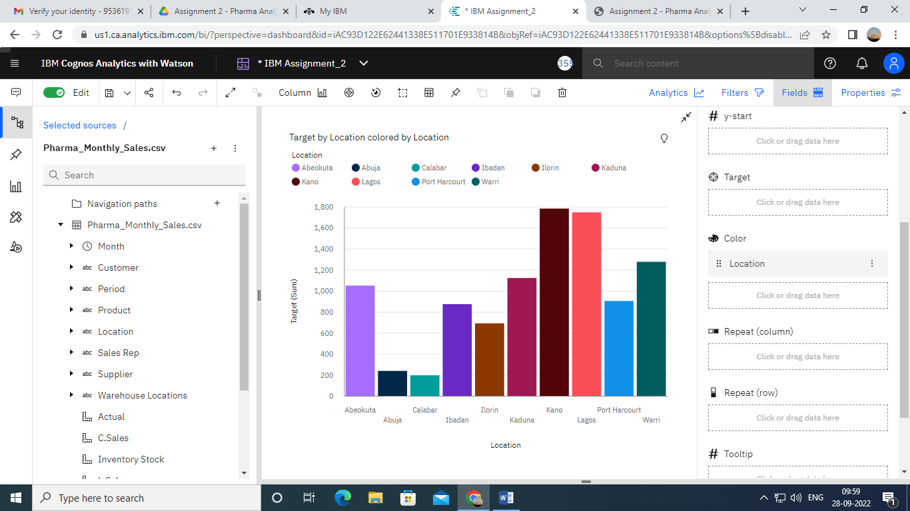

**Task 7:Monthly Sales**

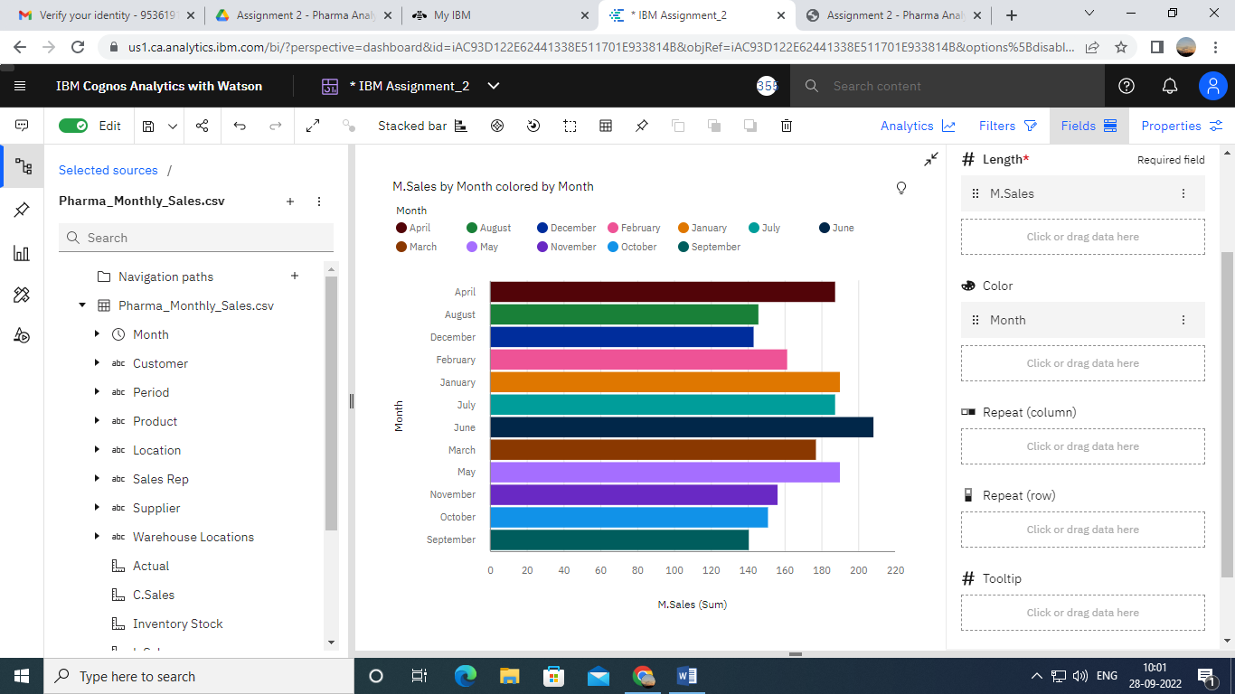

**Task 8: Actual and Received Inventory by Month**

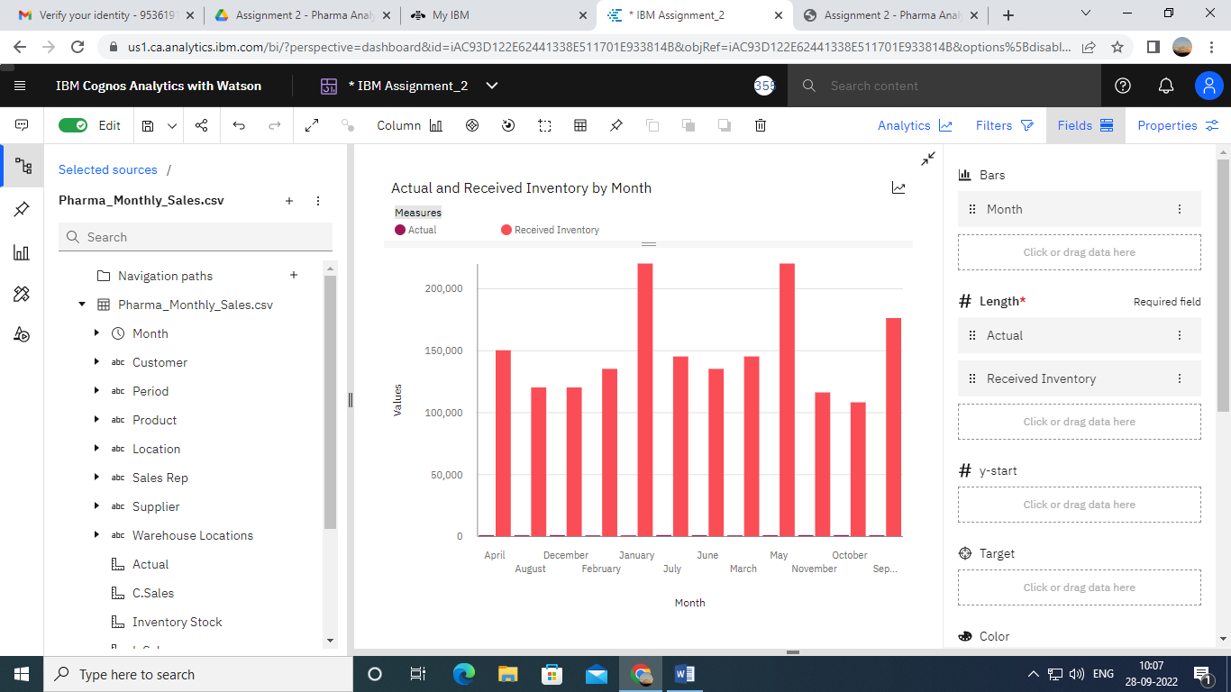

**Final dashboard**

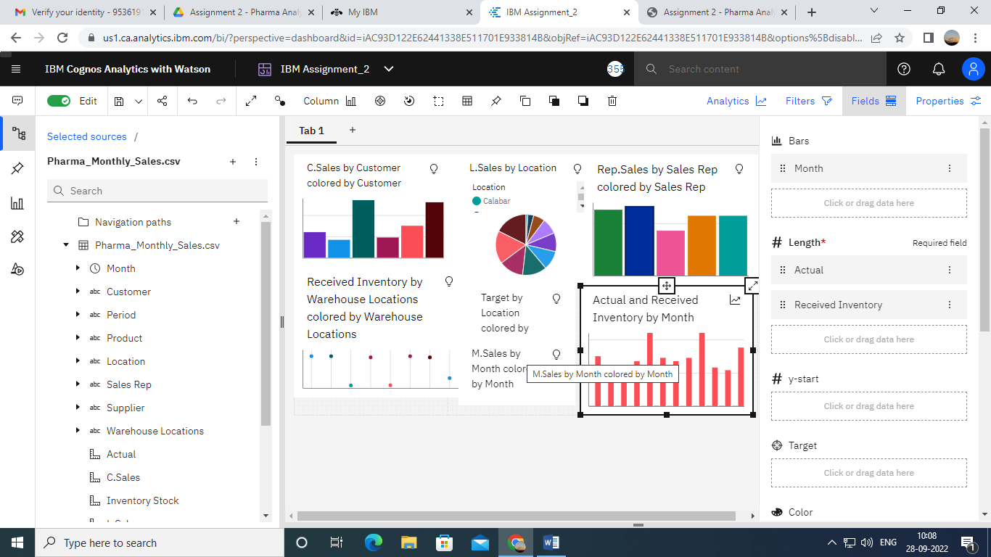

**LINK:**

<https://us1.ca.analytics.ibm.com/bi/?perspective=dashboard&pathRef=.my_folders%2FIBM%2BAssignment%2FIBM%2BAssignment_2&action=view&mode=dashboard&subView=model0000018381d42bb8_00000000>